1. **Prompt for amount, interest rate and no. of years and calculate simple interest.**

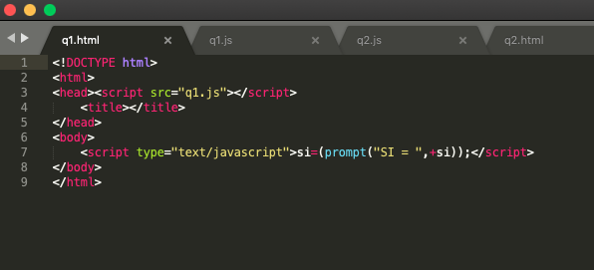

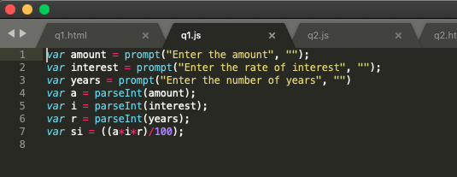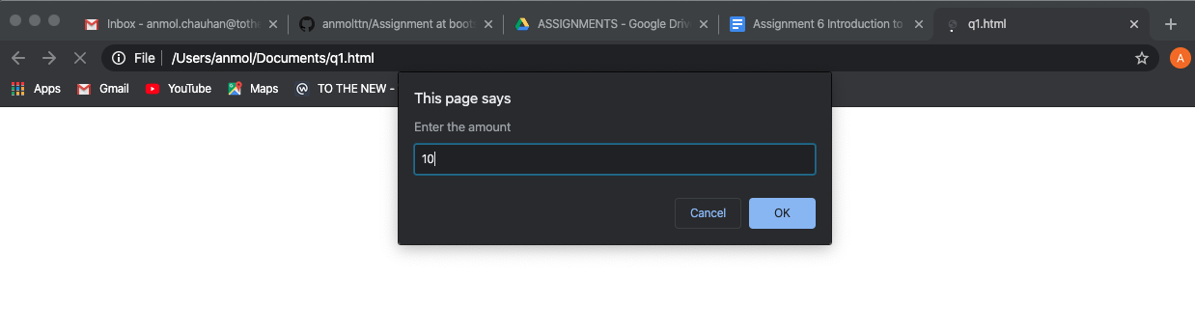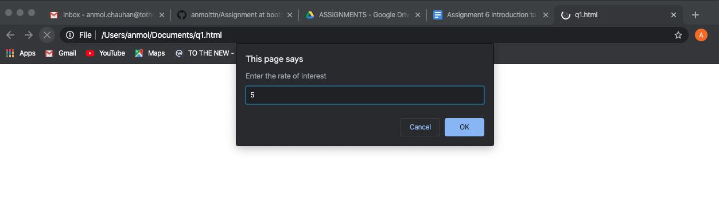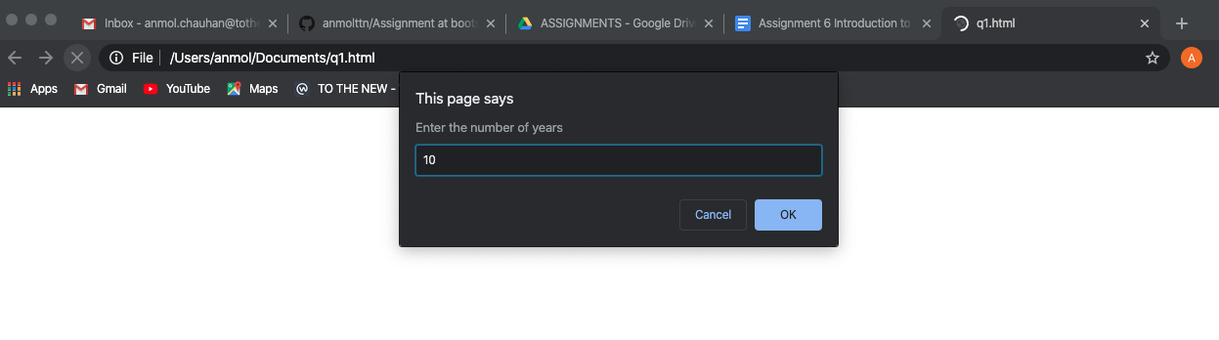

1. **is palindrome string**

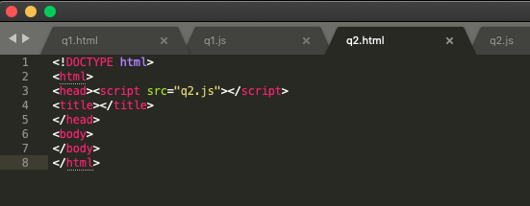

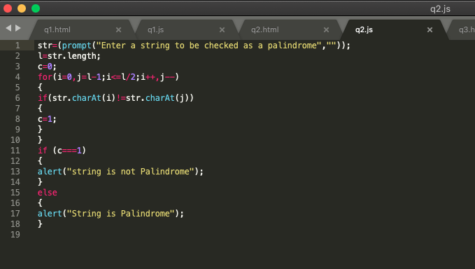

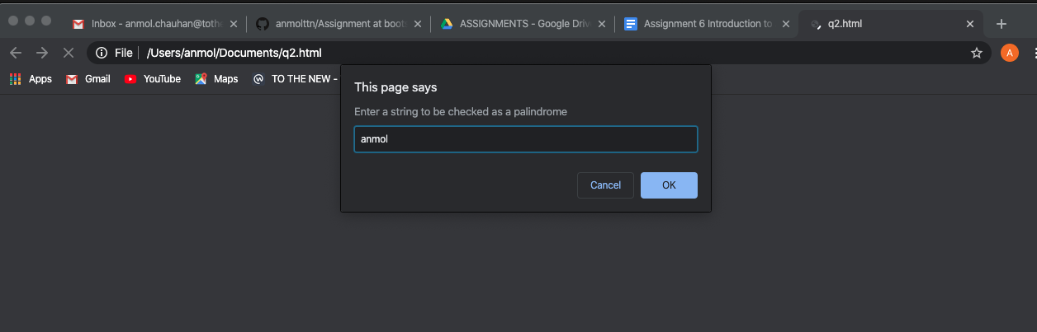

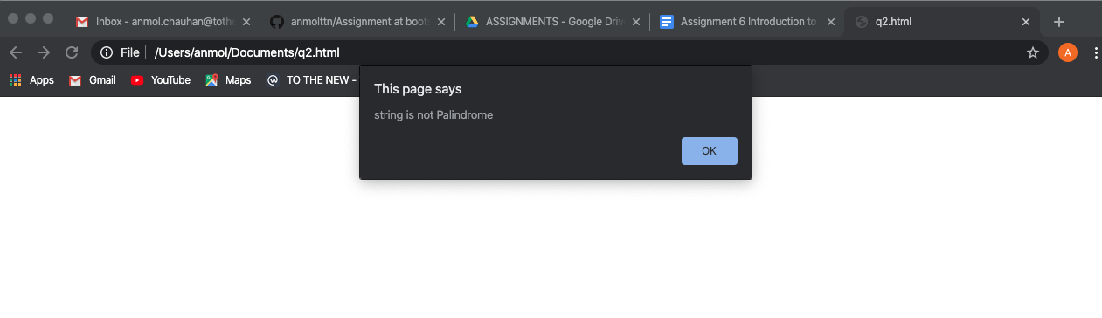

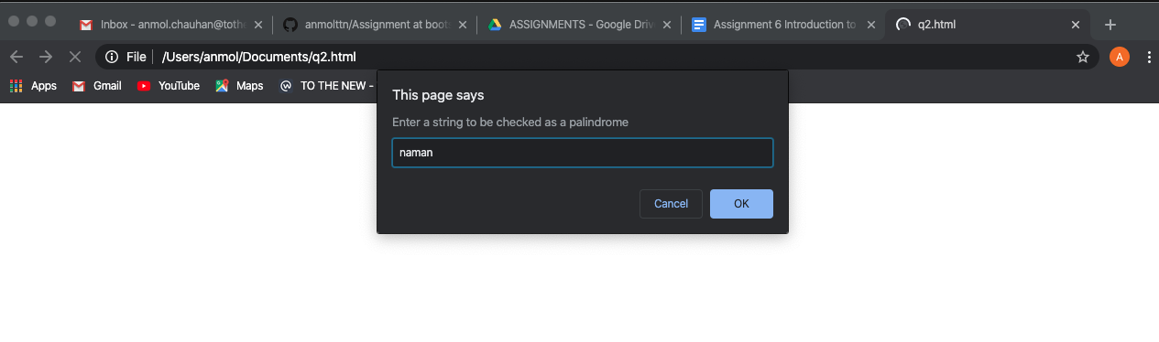

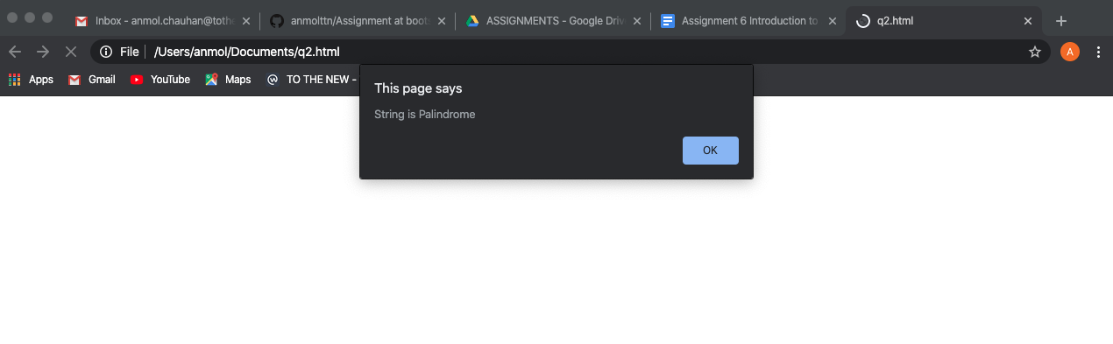

1. **Area of circle**

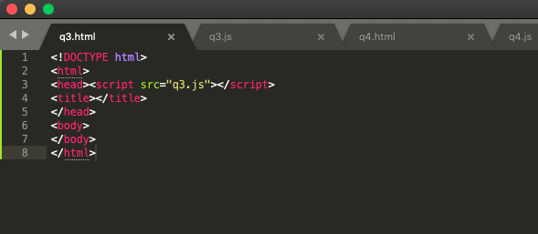

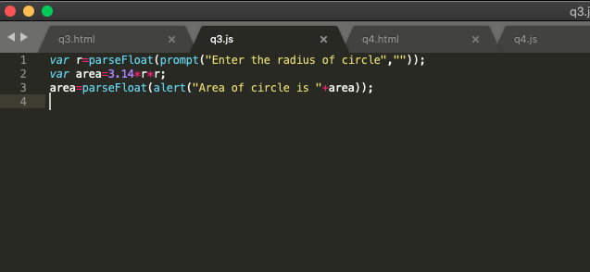

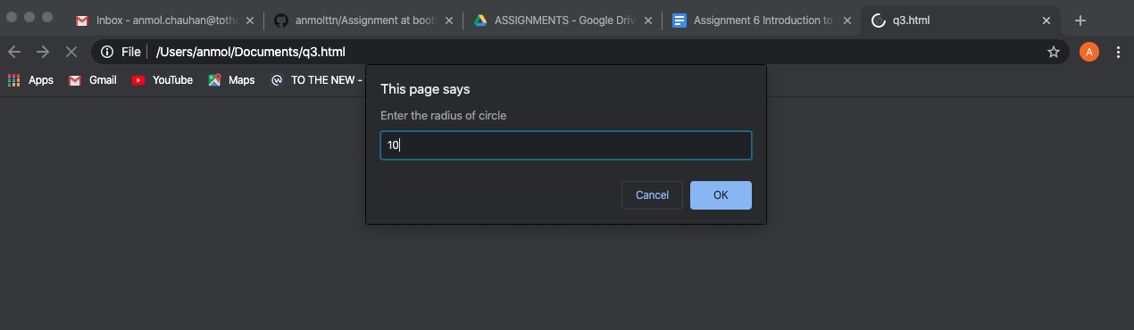

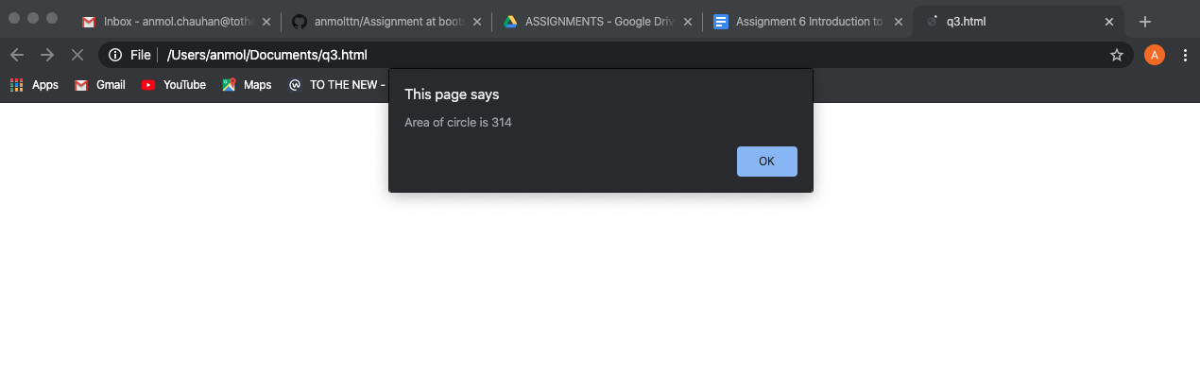

1. **Copy information of one object to another and log it to console.**

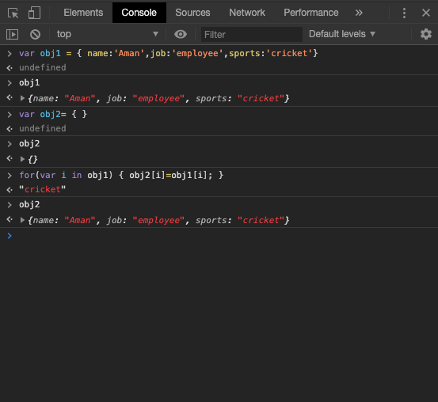

1. **create a list of objects of Employee with info as follow :**

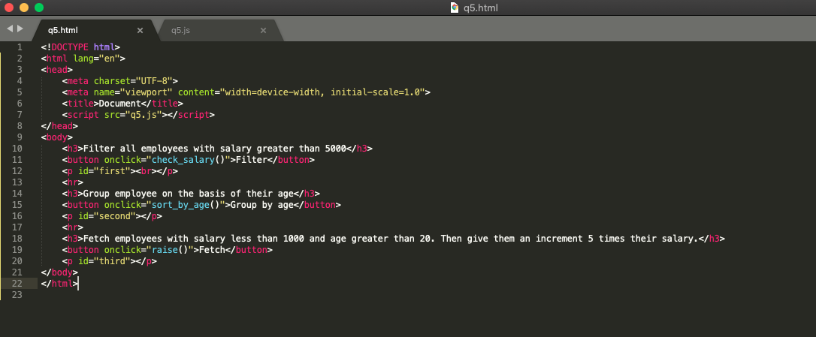

* + **Name, age, salary ,DOB**

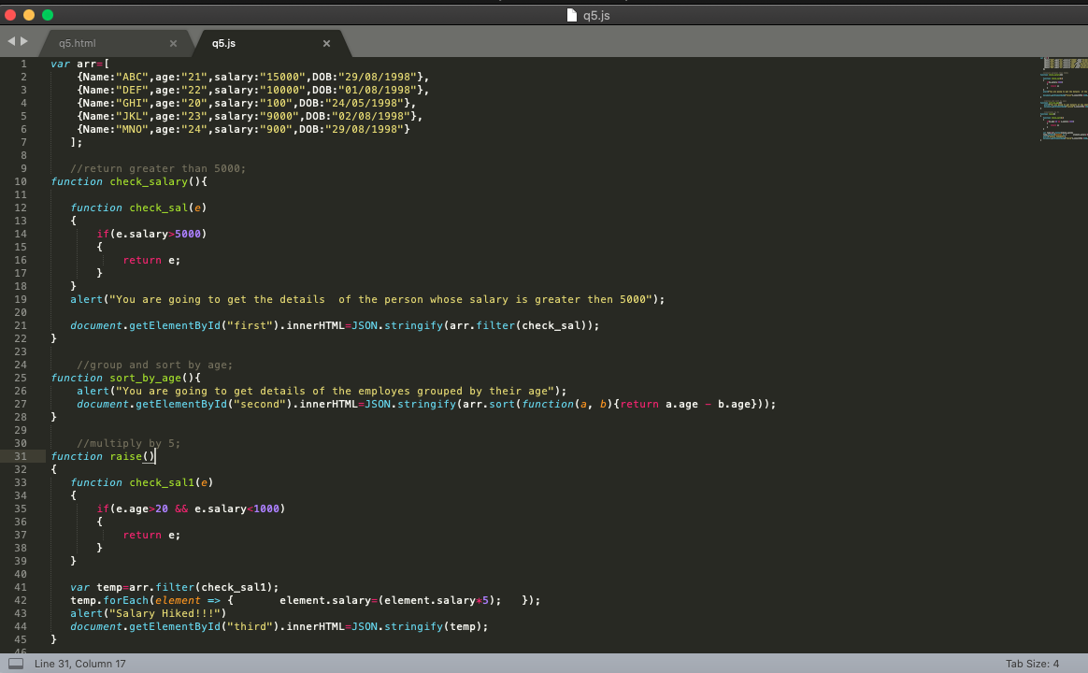

* + **filter all employees with salary greater than 5000**



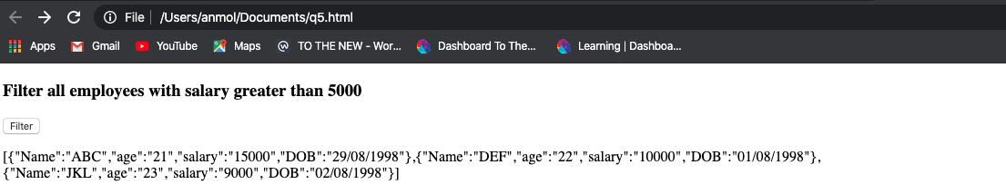

* + **group employee on the basis of their age**

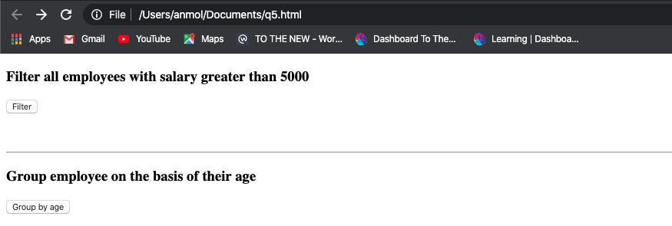

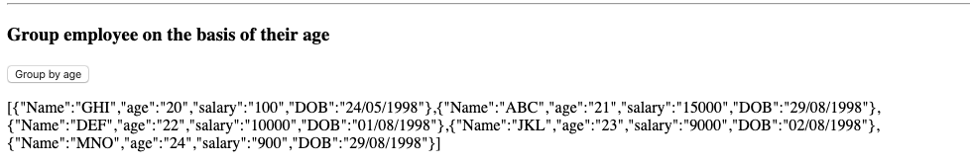

* + **fetch employees with salary less than 1000 and age greater than 20. Then give them an increment 5 times their salary.**

